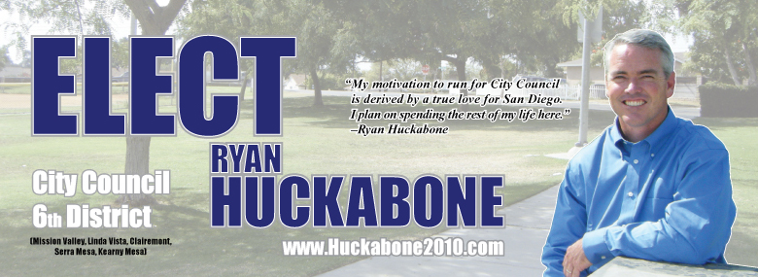

YES! I support Ryan Huckabone for City Council, District 6.

You may use my name in public:___________________________________________________
(Endorsement Signature Required)

Enclosed is my check for $______________
(Please make check payable to Ryan Huckabone for City Council 2010)

*Name:_______________________________________________________________________

*Address (Not a PO Box):_________________________________________________________

Mailing Address:________________________________________________________________
(If different from street address)

Phone:_____________________________ Email:_____________________________________

*Occupation:____________________________________________________________________

*Employer:_____________________________________________________________________

*Required information per campaign laws.

Please read before making a contribution:

- It is unlawful for a contributor to be reimbursed by any organization, business or similar entity for a contribution supporting or opposing a City candidate.
- Contributions are permissible from personal accounts only. No business or corporate contributions, including sole proprietorships, are permitted. Campaign contributions are not tax deductible.
- Contributions by check or credit card are limited by City law to $500 per individual, $1,000 per couple, per election. For joint checking accounts, spouses may write separate checks or write one check signed by both spouses if check exceeds $500.
- Cash and money orders are limited to $99.
- Campaign law requires that we keep on file the occupation, employer and street address for all contributors. List PO Box separately if you prefer that as a mailing address.
- PLEASE NOTE THAT ALL CONTRIBUTIONS WILL BE PUBLICLY DISCLOSED, INCLUDING THOSE UNDER $100.

PAID FOR BY:
RYAN HUCKABONE FOR CITY COUNCIL 2010
5476 VIA CARANCHO, SAN DIEGO, CA 92111
FPPC #1320421

